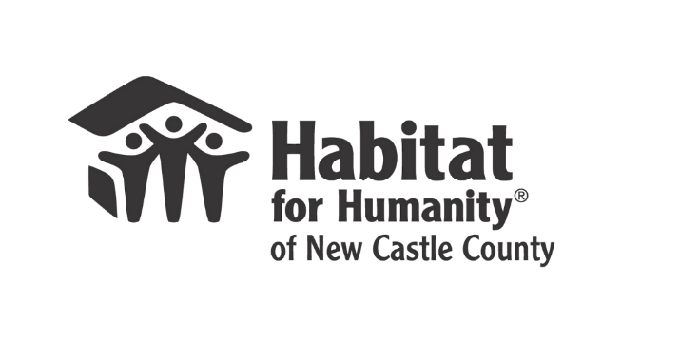
FOR IMMEDIATE RELEASE
Contact: Kathi Barber, Director of Development
KBarber@habitatncc.org
cell 302.300.0533

Habitat for Humanity of New Castle County
Dedicates a New Home Built in Wilmington,
Strengthening Community and Addressing Housing Needs

Wilmington, DE, November 20, 2023 - Habitat for Humanity of New Castle County (Habitat NCC) is excited to announce another new home in Simonds Gardens, a significant step in combating the affordable housing shortage in Wilmington. This new home exemplifies a collaborative effort between the homeowner, Habitat NCC, Wells Fargo, Blenheim Homes, and New Castle County.
**Home Dedication Event Details** November 29, 2023 at 11 am - 116 Pilgrim St., Simonds Gardens, Wilmington, DE
This is a first-of-its-kind partnership between Habitat NCC and Blenheim Homes, under the Moderately Priced Dwelling Units ordinance in New Castle County that fosters community development and sets a precedent for future housing initiatives.
Kevin Smith, CEO of Habitat NCC, expressed his pride in the organization's deep-rooted connection with the Simonds Gardens community. "Our ongoing commitment in Simonds Gardens has been multifaceted, encompassing new home constructions, essential repairs, and wide-reaching neighborhood revitalization efforts," said Smith.
Habitat NCC continues to lead the way in affordable housing solutions, ensuring that more families in New Castle County have a place to call home. The dedication and collaboration exhibited in these projects are a testament to the power of community and partnership in creating meaningful change.
About Habitat for Humanity of New Castle County
Since 1986, Habitat for Humanity of New Castle County (HFHNCC) has built over 290 homes and served over 1,000 families. Committed to changing lives and landscapes, HFHNCC provides affordable housing solutions for low-income families. Habitat engages residents in improving their neighborhoods, provides free critical home repairs to preserve existing homeownership, provides interventions so that older adults can age in place, builds affordable housing, and conducts financial literacy and home maintenance education for families in our homeownership program.

