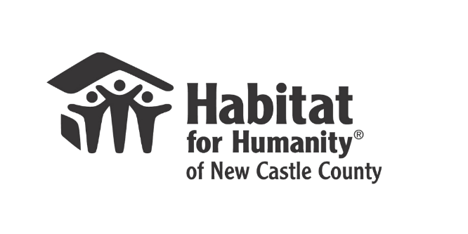

FOR IMMEDIATE RELEASE
Ken Briscoe, Jr., Director of Communications Kathi Barber, Director of Development Kenneth.briscoe@delaware.gov KBarber@habitatncc.org
302-276-6053 302-300-0533

Governor Carney, Delaware State Housing Authority and Habitat for Humanity of New Castle County Join Forces to Promote Homeownership Month
Wilmington, DE, May 31, 2024 – Habitat for Humanity of New Castle County (HFHNCC) and Delaware State Housing Authority (DSHA), in partnership with Governor John Carney’s office, are proud to announce a press conference to highlight their efforts in supporting homeownership and community development across Wilmington and the entire state of Delaware. The press conference, which takes place during National Homeownership Month, celebrates the value that owning a home brings to families, communities, and neighborhoods across America.
Date: Wednesday, June 5, 2024
Time: 11am – 12pm
Location: 718 Pine Street, Wilmington, DE 19801

The event will bring together key stakeholders, critical repairs recipients, and members of the public to discuss the significant impact of the partnership between DSHA and HFHNCC, including critical repairs and aging-in-place interventions, which have been instrumental in improving the quality of life for residents in Delaware.
Habitat for Humanity of New Castle County will provide an overview of their expanding initiatives that address urgent housing repairs and support aging residents to remain safely in their homes. DSHA will share information about their 203K program – “Diamonds in the Rough” – which allows new homeowners to finance up to $35,000 of their mortgage loan to eliminate the financial barriers for home repairs, improvements, or upgrades, making rehab properties livable spaces for families for years to come.
Speakers will include:
Governor John Carney
Cynthia Karnai – Director, Delaware State Housing Authority
Wilmington Mayor Mike Purzycki
Kevin L. Smith – Chief Executive Officer, Habitat for Humanity of New Castle County
Bettina Tweardy Riveros – Chief Public Affairs and Chief Health Equity Officer, Christiana Care
Homeowners
The critical repairs program is designed to address essential home repairs that impact homeowners' health, safety, and overall well-being. By providing these services, HFHNCC ensures that families can live in safe, stable, and affordable homes. The aging-in-place program focuses on modifications and improvements that allow elderly residents to continue living independently in their homes, maintaining the More than 50 homeowners have benefitted from this DSHA/HFHNCC partnership this year alone.
“We are investing in our neighborhoods and revitalizing Delaware’s communities. By providing homeowners with the financial means to renovate their properties, we are empowering individuals to transform their homes and revitalize neighborhoods, creating a ripple effect of positive change and growth within communities,” stated Governor John Carney.
Kevin L. Smith, CEO of HFHNCC, added, “We are thrilled to work with the State of Delaware and Governor Carney’s office to amplify our efforts in Wilmington and beyond. Most people know us for building homes, and through our critical repairs and aging-in-place programs we are also able to sustain homeownership.”

“The City of Wilmington was proud to provide funding to Habitat for Humanity. Through two lotteries, we successfully distributed approximately $1.7 million to 160 Wilmington homeowners to be used solely for home improvements, said Mike Purzycki, Mayor of Wilmington.

“Homeownership is a vital part of DSHA’s mission. Every day, our team is developing innovative and beneficial ways to help Delaware residents access quality, affordable homes,” said Cynthia Karnai, Director of DSHA. “This month we celebrate the role that homeowners play in enhancing our communities and driving Delaware’s economy forward.”
The press conference will provide an opportunity for the media and the public to learn more about these initiatives and hear firsthand from those whose lives have been positively impacted. Attendees will also learn about DSHA programs that support homeownership.
Water ice will be served at the press conference, courtesy of DSHA.
XXX
About Delaware State Housing Authority: Formed in 1968, Delaware State Housing Authority (DSHA) is dedicated to providing quality, affordable housing opportunities and appropriate supportive services to low- and moderate-income Delawareans. In addition to its role as the State's Housing Finance Agency, DSHA is unique in that it serves as a Public Housing Authority and a Community Development and Planning Agency. As a Public Housing Authority, DSHA receives funding from HUD to build, own and operate public housing in Kent and Sussex counties, two of Delaware's three counties.
About Habitat for Humanity of New Castle County: Since 1986, Habitat for Humanity of New Castle County (HFHNCC) has built over 300 homes and served over 850 families. Committed to changing lives and landscapes, HFHNCC provides affordable housing solutions for low-income families. Habitat engages residents in improving their neighborhoods, provides free critical home repairs to preserve existing homeownership, provides interventions so that older adults can age in place, builds affordable housing, and conducts financial literacy and home maintenance education for families in our homeownership program.

